BANGLADESH UNIVERSITY OF BUSINESS
AND TECHNOLOGY (BUBT)

A project
On
YOUR PROJECT TITLE



Course Code: CSE 200
COURSE TITLE: Software Development II

SUBMITTED BY

Name | ID
Md. Sakhawat Hossain | 16172103046
Md. Nayim Islam | 16172103033
Md. Mahadi Hasan | 16172103028
Mst. Laboni Khatun | 16172103214
SUBMITTED TO

Md. Masudul Islam
Lecturer, Dept. of CSE
BUBT

Submission Date: 03th, March, 2019

TABLE OF CONTENTS

Ch. | Chapter Title | Page No.
1 | Abstract | 3
2 | Features | 3
3 | Existing System Analysis | 4
4 | Technology & Literature Review | 5-6
5 | System Design  - USE Case Diagram  - DFD (All level)  - UML Class Diagram | 7-8
6 | Project Planning  - Team Information  - Working Breakdown Structures  - Time Schedule | 9
7 | Software & Hardware Requirements | 9
8 | User Manuals  - Template Screenshot  - Screen View of Various Functionalities | 10-11
9 | Conclusion/Limitation & Future Works | 12

- ABSTRACT
Banking Record System:

The Bank Account Management System is an application for maintaining a person's account in a bank. In this project I tried to show the working of a banking account system and cover the basic functionality of a Bank Account Management System. To develop a project for solving financial applications of a customer in banking environment in order to nurture the needs of an end banking user by providing various ways to perform banking tasks. Also to enable the user’s work space to have additional functionalities which are not provided under a conventional banking project. As we are beginners and have no practical experience in the field of software development and moreover the Banking System is very wide. So, we limit the scope of our project by computerizing the following fields of the Banking System: -

- Feature
The feature of banking record system are:
- Add Record:
- Show/List Data:
- Search Record:
- Edit Record:
- Delete Record:

- Existing System Analysis

3.1: Bank Account Management System
Website Link: https://www.researchgate.net/publication/301293322_Bank_Account_Management_System

The Bank Account Management System undertaken as a project is based on relevant Technologies.The main aim of this project is to develop software for Bank Account Management System. This project has been developed to carry out the processes easily and quickly, which is not possible with the manuals systems, which are overcome by this software.

3.2: Banking Record System.

Website Link: http://yesfreeprojects.blogspot.com/2017/05/banking-record-system-c-project.html

For this feature void read_data() function has been used to add banking record into the file. With the information provided in add record, the void show_data() function in this banking record system project in C++ show the record corresponding to a particular account number, first name and last name.

4.Technology & Literature Review:

4.1: Tools & Technology:

Serial No. | Name
1. | code blocks
2. | Processor
3. | Main Memory(RAM)
4. | Hard Disk
5. | Operating System

4.2: Literature Review:

- Object Oriented Programming (OOP):

Object-oriented programming (OOP) is a programming language model organized around the object rather than "actions" and data rather than logic. Historically, a program has been viewed as a logical procedure that takes input data, processes it, and produces output data.

- Data Abstraction.

Data abstraction is the reduction of a particular body of data to a simplified representation of the whole. Abstraction, in general, is the process of taking away or removing characteristics from something in order to reduce it to a set of essential characteristics.

- Polymorphism.

In object-oriented programming, polymorphism is the characteristic of being able to assign a different meaning or usage to something in different contexts - specifically, to allow an entity such as a variable, a function, or an object to have more than one form. There are several different kinds of polymorphism.

- Inheritance

The capability of a class to derive properties and characteristics from another class is called Inheritance. Inheritance is one of the most important feature of Object Oriented Programming.

- Class:

The main purpose of C++ programming is to add object orientation to the C programming language and classes are the central feature of C++ that supports object-oriented programming and are often called user-defined types.

- Object:

A class provides the blueprints for objects, so basically an object is created from a class. We declare objects of a class with exactly the same sort of declaration that we declare variables of basic types.

- Private:

A private member variable or function cannot be accessed, or even viewed from outside the class. Only the class and friend functions can access private members.

- Public:

A public member is accessible from anywhere outside the class but within a program.

- Protected:

A protected member variable or function is very similar to a private member but it provided one additional benefit that they can be accessed in child classes which are called derived classes.

5. System Design:

- USE Case Diagram:
Customer
Manager

Information

Services

DFD:

3. Update Process

USER
2. Account Create Process
2. Account File
USER
1. Account File

2. Show Info file

3. Delete Process

UML Class Diagram :

account_query

# account_number
# firstName
# lastName
# total_Balance

- read_data()
- show_data()
- write_rec()
- read_rec()
- search_rec()
- edit_rec()
- delete_rec()

6. Project Planning:

Phase | ID | Activity | Duration
Analysis | 16172103033 | - Data Gathering  - Data Flow | 20 Hour.  20 Hour.
Design | 16172103028 | - Data Entity Design | 30 Hour.
Implement | 16172103046  16172103214 | - Implement Code  - Testing & Debug  - Documentation & Repot  - Protection Make | 30 Hour.  40 Hour.  20 Hour  40 Hour.

7. Software & Hardware Requirements:

- Processor : Intel Pentium III or later
- Main Memory (RAM) : 256 MB
- Cache Memory : 512 KB
- Monitor : 14 inch Color Monitor
- Keyboard : 108 Keys
- Mouse : Optical Mouse
- Hard Disk : 160 GB
- Operating System : Windows 7, 8, 9, 10, XP

8. User Manuals:

Template Screenshot :-

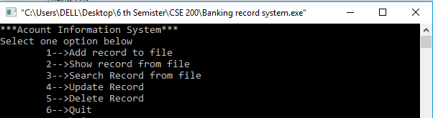

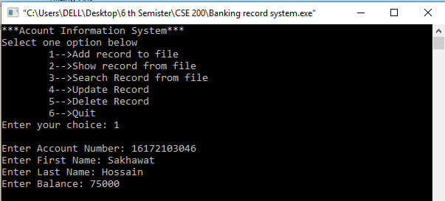

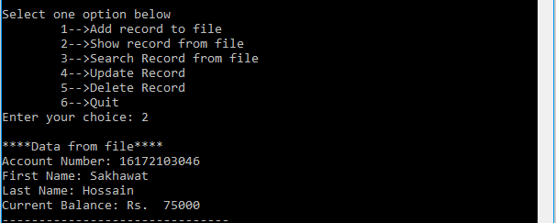

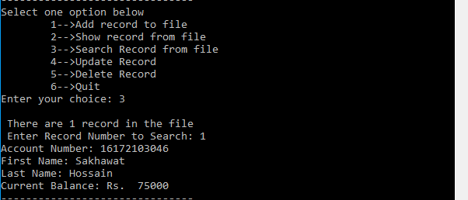
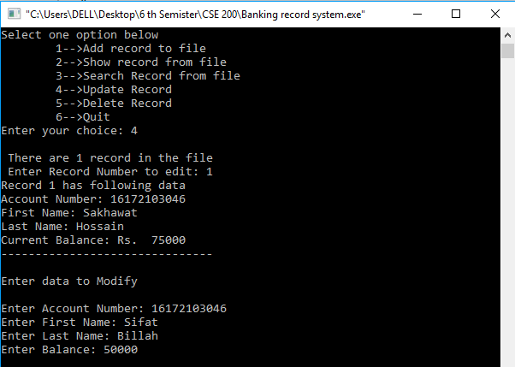

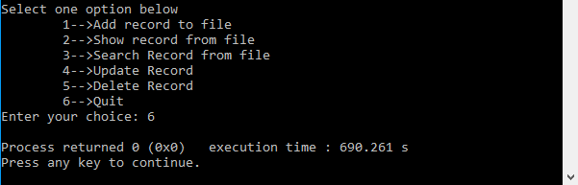

9. Conclusion/Limitation & Future Works:

The “Banking Record System is a big and ambitious project. I am thankful for being provided this great opportunity to work on it. As already mentioned, this project has gone through extensive research work. On the basis of the research work, we have successfully designed and implemented banking Record System.
The most valuable future looks are following below:

1. More branches of the bank, maybe it will be international, that means
more ATM machines outside.

2. Customer issues development based on their needs, so the help desk will be aware of their needs and easy to use.

3. Developing a mobile App for banking system that help users to do the obtained his operations without go to the bank only he need to sign in using his A/C NO. And password and then use your own PIN. Finally, the system will update automatically.

This project is developed to nurture the needs of a user in a banking sector by embedding all the tasks of transactions taking place in a bank. Future version of this project will still be much enhanced than the current version.
Thus the Bank Management System it is developed and executed successfully.

